**Experiment no –01 (C)**

**Aim:** Write a program to generate the Fibonacci series.

**Program:**

**Code:**

def fib(n):

a = 0

b = 1

if n == 1:

print(a)

else:

print(a)

print(b)

for i in range(2,n):

c = a + b

a = b

b = c

print(c)

fib(10)

**OUTPUT:**

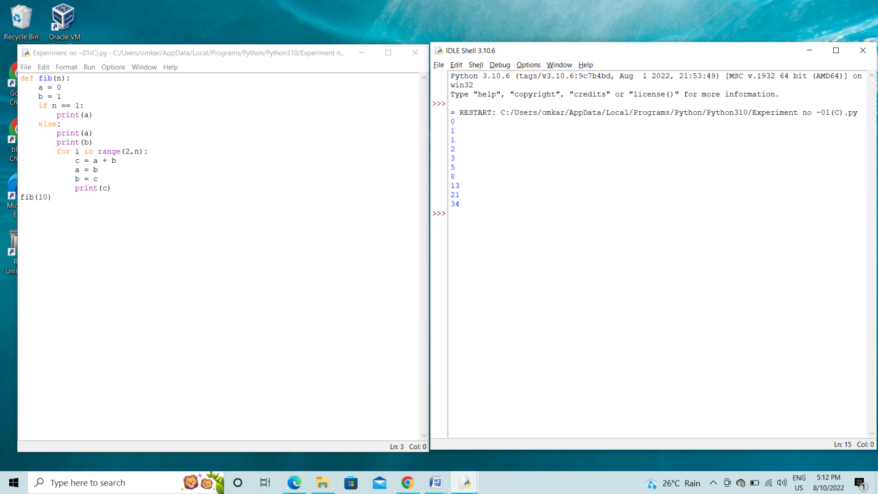

**Conclusion :** This is program successfully run.